**Outlines**

MULTIPROCESSING

TASK SCHEDULER

**Multiprocessing**

This section introduces two method of multiprocessing

**Method1:Pool**

Sample code:

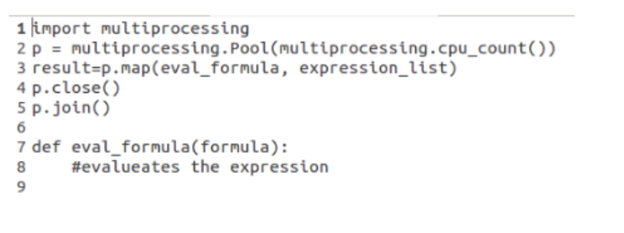

Change the eval_formula to the function you want to multiprocess, and change ecpression_list as the input list for the function.

**Method 2:Process**

Sample code:

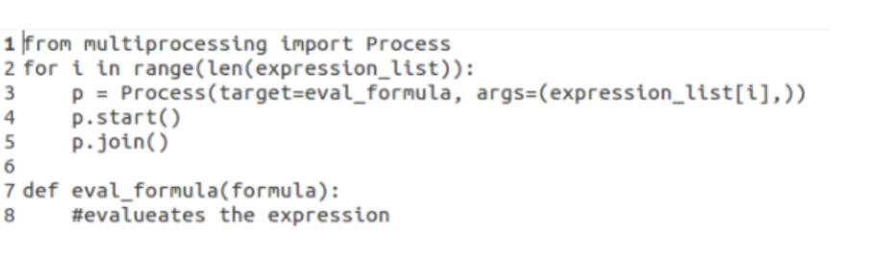

Change the eval_formula to the function you want to multiprocess, and change ecpression_list as the input list for the function.

**TASK SCHEDULER**

Task scheduler can be achieved on Linux by creating cron jobs.

Steps:

1. Open bash terminal in mac and type Crontab -e

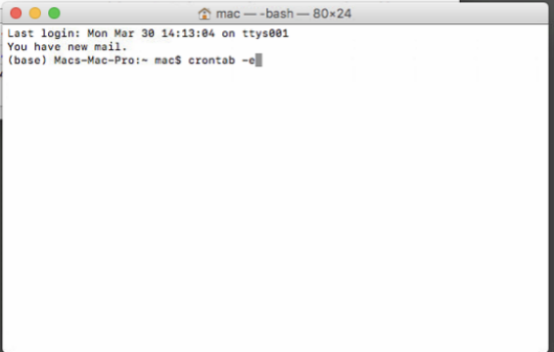

1. Hit ‘i’ to put the editor into INSERT mode, and type the below cron expression in terminal:

DATE EXPRESSION cd PATH OF THE FILE YOU WANT TO SCHEDULED && /Users/mac/anaconda3/bin/python FILE YOU WANT TO SCHEDULED

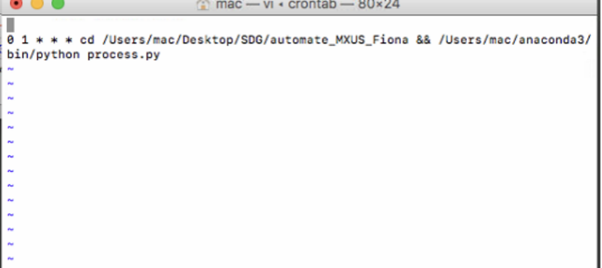

For example: you want to run the process.py every day at 1:00 am. The process.py is under the path: ‘/Users/mac/Desktop/SDG/automate_MXUS_Fiona’.

Then the cron expression is:

0 1 * * * cd /Users/mac/Desktop/SDG/automate_MXUS_Fiona && /Users/mac/anaconda3/bin/python FILE YOU WANT TO SCHEDULED

Here:

cd /Users/mac/Desktop/SDG/automate_MXUS_Fiona is the path of the process.py. /Users/mac/anaconda3/bin/python is the location of the Python

How to set DATE EXPRESSION:

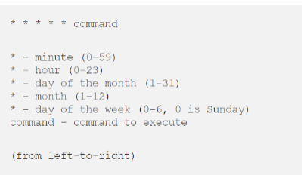

1. Hit esc and then type : wq